**CS7GV1 Computer Vision**

Cormac Madden - Mid-term Project 2022/23

**Part 1: Photo effects**

For each of the following photo filters, many of the processing steps are similar, such as splitting the image into its 3 channels (RGB), clipping the values between 0 and 255 and converting them to integers.

For each of these tasks I created functions that are called where needed in each filter.

The **split** function takes the img array as an input and returns three 1D arrays of the R, G and B channels.

def split(img):

    b = img[:,:,0]

    g = img[:,:,1]

    r = img[:,:,2]

    rgb = r,g,b

    return rgb

The **clipping** function takes an array as input and uses the numpy clip function to limit the array to values between 0 and 255.

def clip(r,g,b):

    b = np.clip(b,0,255)

    r = np.clip(r,0,255)

    g = np.clip(g,0,255)

    return r,g,b

The **convert_to_int** function takes an array as input that is typically filled with float values and returns the array converted to integers.

def to_uint8(r,g,b):

    b=b.astype('uint8')

    g=g.astype('uint8')

    r=r.astype('uint8')

    return r,g,b

1. **Exposure Filter**

My implementation of the exposure filter is to add the original color value multiplied by a fraction of the input and 255. This ensures the blacks stay black and the brightness is increased proportionally.   
F(C,amt) = C + C(amt/255)

I think this is a reasonable implementation because it avoids the issue of faded blacks when you increase every pixel by the same amount.

    r = r[:,:] + ((r[:,:]/255) * amt)

    g = g[:,:] + ((g[:,:]/255) * amt)

    b = b[:,:] + ((b[:,:]/255) * amt)

1. **Contrast Filter**

There are many different interpretations as to how a contrast filter should be applied to an image. In essence it needs to increase the distance between all the values in the image. However, this can have unintended consequences on the colour of the image and perform strangely in dark or bright regions if not implemented correctly.

To adjust the contrast, I created a function that takes the image and a value between 0.5 and 2 as input. The formula I found that gave the most reasonable results is as follows:

F(C,amt) = (C-128) * amt + 128

    r = (r-128) * contrast + 128

    g = (g-128) * contrast + 128

    b = (b-128) * contrast + 128

The resultant images resembled the same effect for when I applied a similar amount of contrast to an image in photoshop. This is a useful filter for when you are trying to create more defined edges in an image to perhaps be detected by an edge detection filter.

1. **Temperature Filter**

To adjust the temperature I created a function that takes the image and an amount as a parameter.

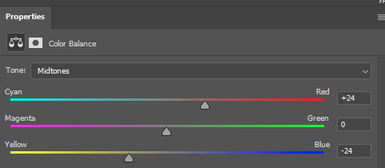The Input parameter can range from -100 to 100. Positive values will make the image look warmer and negative values will make the image look cooler.

To make the image warmer the input amount is added to each pixel in the red channel and subtracted from the blue channel. When a negative value is used as a parameter the inverse operation is performed. The blue channel is increased and red decreases.

b = b[:,:] - amt

r = r[:,:] + amt

This is typically the method used in photoshop to adjust the colour balance of an image.

This filter could be useful when the camera doesn’t calculate the correct white balance for an image or when a warmer or cooler look is desired.

1. **Tint Image**

The tint function operates similarly to the temperature filter with the same inputs of the image and an amount ranging from -100 to +100. The function has the same functionality as the middle slider in the photoshop screenshot above. Positive values will make the image look greener and negative values will make the image look more magenta.

    g = g[:,:] + amt

This filter could be useful when the camera doesn’t calculate the correct white balance for an image.

1. **Binary Image filter (Thresholding)**

The function I used to create a binary image takes the image and an integer between 0 and 255 as input. It first converts the image to greyscale using the filter described above. It then loops through each pixel in the image and checks if the value of the pixel is above or below the input value.

If it is below, the value of the pixel is changed to black and if it is equal or higher it is set to 255.

            if(greyed[i,j]<amt):greyed[i,j] = 0

            else: greyed[i,j] = 255

1. **Solarization & Inverting**

To invert the images, I multiplied all the pixels in each channel by -1 and then added 255.

    r = r*(-1) + 255

    g = g*(-1) + 255

    b = b*(-1) + 255

My interpretation is that the solarization filter is where in photography the image is recorded on a negative or on a photographic print for too long and the bright areas of the image become inverted.

                if(pix > threshold):

                    pix = pix*(-1) + 255

                    pix = pix.astype('uint8')

                    output[i,j, rgb] = pix

For this I did the same as for inverted except added an if statement that checks it’s above a certain threshold and put it in a for loop that loops over every pixel in each channel

Solarization is more of a novel effect, but the invert filter could be useful for inverting binary masks.

1. **Image Flip Horizontal and Vertical**

I created two filters to flip in either the horizontal or vertical direction. They both create an empty array and fill it using the original image pixels in reverse order.

for i in range(img.shape[0]):

        for j in range(img.shape[1]):

            output[i,j] = b[i,img.shape[1]-1-j], g[i,img.shape[1]-1-j], r[i,img.shape[1]-1-j]

It’s useful for creating mirrored images or for creating more training data for a machine learning model.

1. **Greyscale Filter**

There are many ways to convert an image to greyscale. The goal is to maintain the same luminance as the original image and to have the dark and bright areas appear as would be expected by the human eye.

The image must first be gamma corrected because the input rgb likely has a gamma compression function applied to it. This can be performed with the following formula.

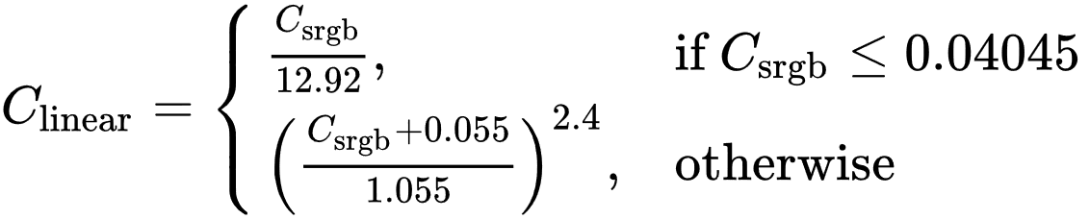

    #Gamma expansion

    for i in range(r.shape[0]):

        for j in range(r.shape[1]):

            if(r[i,j] < 0.04045): r[i,j] = r[i,j]/12.92

            if(b[i,j] < 0.04045): b[i,j] = b[i,j]/12.92

            if(g[i,j] < 0.04045): g[i,j] = g[i,j]/12.92

    r = ((r+0.055)/1.055)**2.4

    g = ((g+0.055)/1.055)**2.4

    b = ((b+0.055)/1.055)**2.4

The human eye is more sensitive to certain colours more than others. Because of this each of the channels are weighted before being added together to form the final image. Green gets the highest weight at 0.7152 and Blue has a weight of 0.0722. The human eye is a lot more sensitive to green light than blue.

    Y = 0.2126*r + 0.7152*g + 0.0722*b

Each pixel then needs to be gamma compressed to be converted back to the typical non-linear sRGB representation.

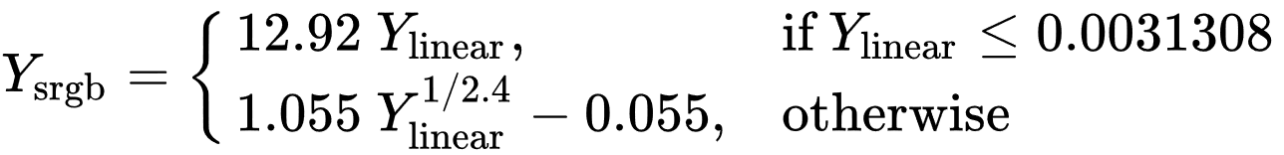

    #Gamma Compression

    output = np.zeros((img.shape[0],img.shape[1],1))

    for i in range(img.shape[0]):

        for j in range(img.shape[1]):

            if Y[i,j] <= 0.0031308:

                output[i,j] = 12.92*Y[i,j]

            else:

                output[i,j] = (1.055*(Y[i,j]**(1/2.4)))-0.055

Converting an image to greyscale is useful for many reasons. It reduces the data needed to store the image by three-fold, it can make it easier to visualize other data in the image, it can also be used for novel reasons like imitating old photos and films.

**Part 1 Images**  
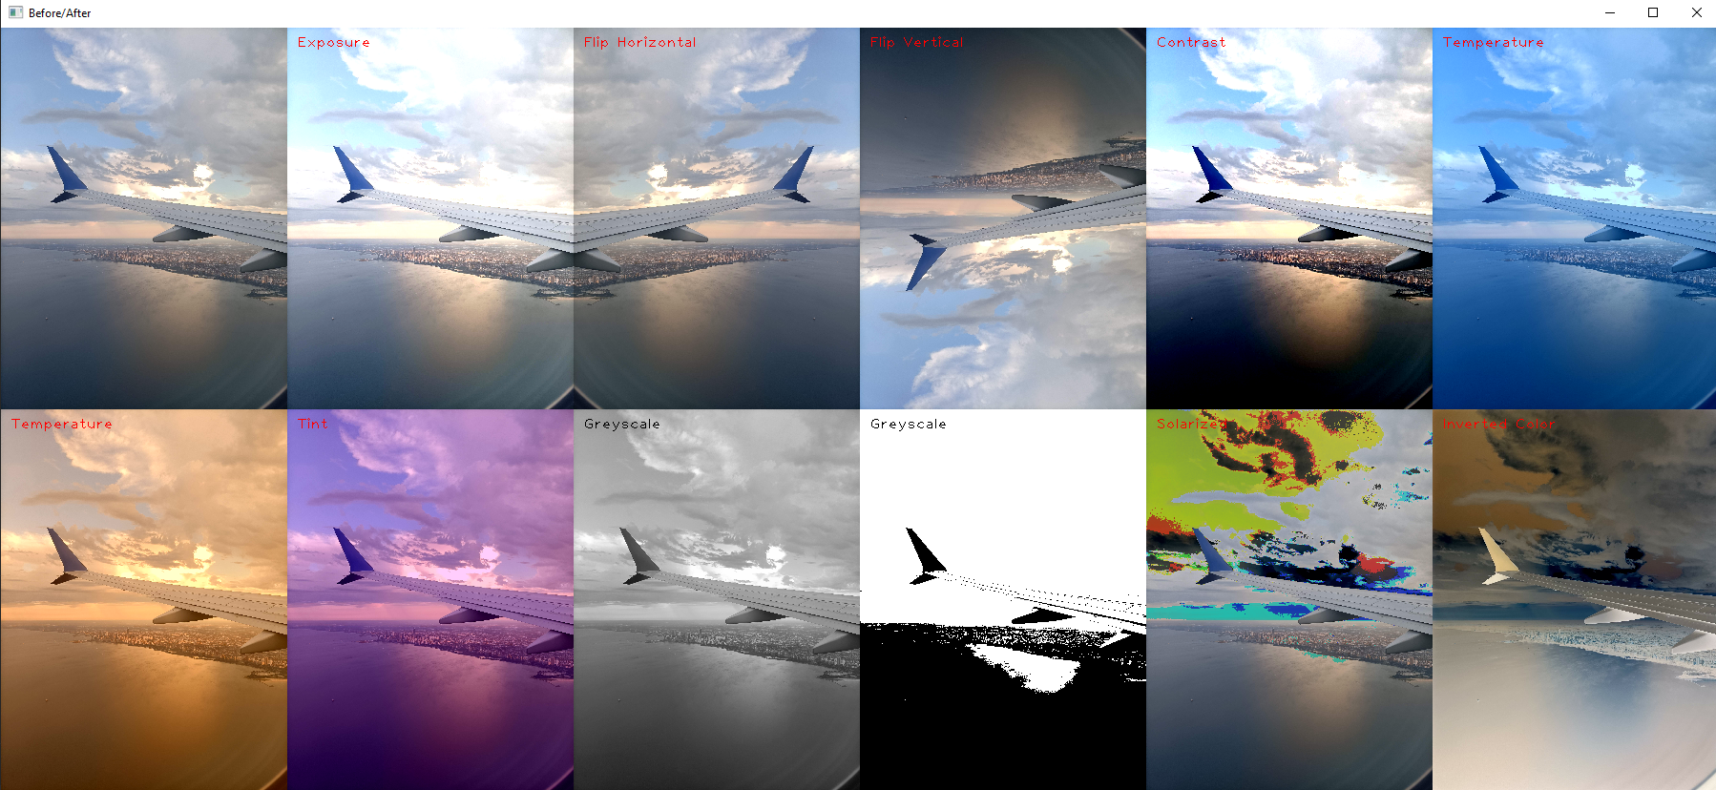

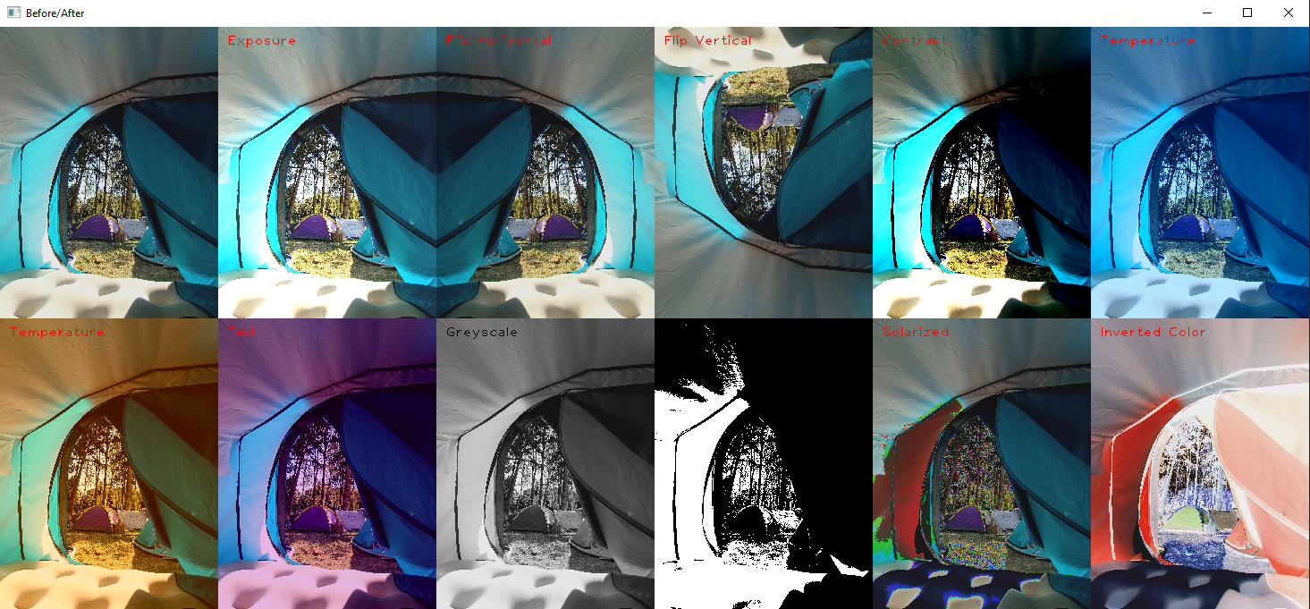

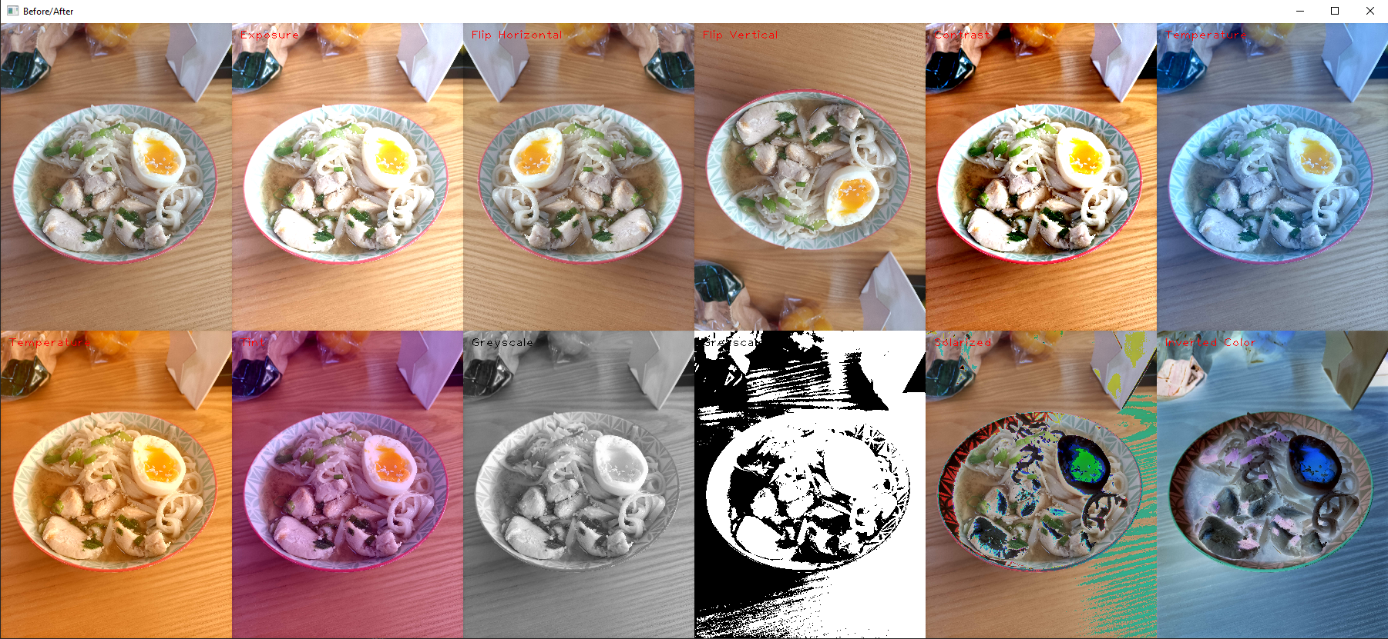

**Part 2: Sharpening, Blur, and Noise Removal**

Similarly, to part 1, many of these filters required several similar tasks to be performed.   
For this I created several extra functions, which include:

**Two convolution functions** used to traverse the image for any input feature. One function is for 3D kernels, to be used on rgb images and the other is for 2D kernels to be used on greyscale images. They operate similarly by iterating over each pixel in the image and extracting a region of interest (ROI) to be multiplied by the normalized kernel. It then saves the resultant pixel to the new output image.

A **padding function** which takes the image and a given kernel as input and returns the image with the outer pixels duplicated as padding. The width of the padding is half the width of the input kernel.

A **normalizing_kernel function** which takes a kernel and normalizes the values so that they all add up to 1.

A **show_kernel and show_ROI function** which converts the kernel or ROI to an uint8 array, scales it by 15 fold and displays it to the screen. This was frequently used to debug the code and track the progress of a convolution filter.

1. **Box Blur (Softening)**

To implement box blur I created a kernel with all the same values and normalized it.

I then used the convolution function I created to apply the kernel to every pixel in the image.

The result is a blurry image that performs questionably on sharp corners or narrow regions of color.

1. **Gaussian Blur (Softening)**

To implement gaussian blur, I created a function that takes a width and returns a normalized kernel with a gaussian distribution of values around the centre. This kernel is then applied to every pixel in the image using the same convolution function as before.

This solution gives arguably a better result than box blur, the corners of the t-shirt in the image are more rounded and the arm on the left is less of a mess. The gaussian filter is round compared to box filter so the blur more closely resembles that of a camera lens or of our eyes.

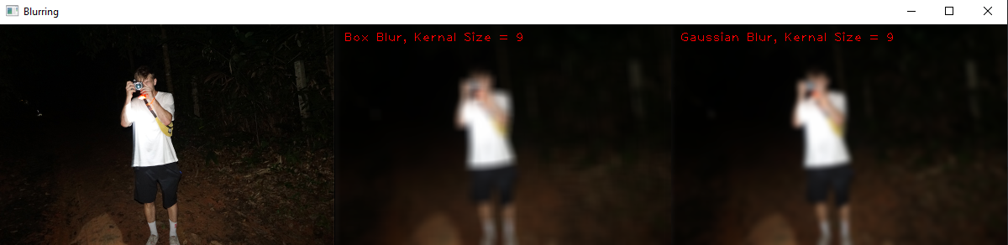

1. **Sharpening Filter (Sharpening)**

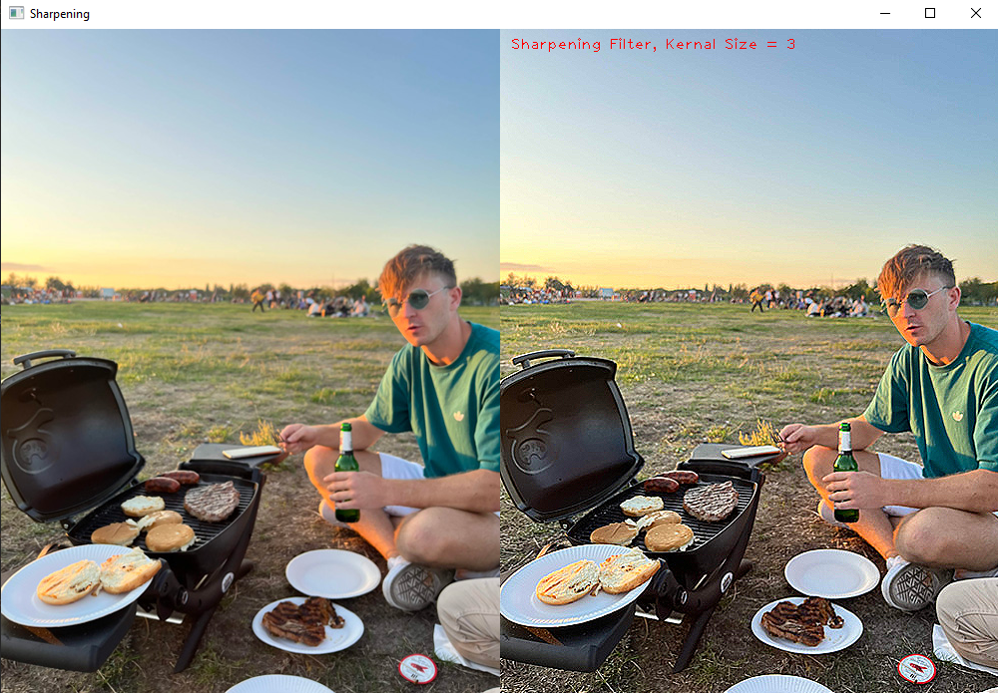

**Unsharp masking?**

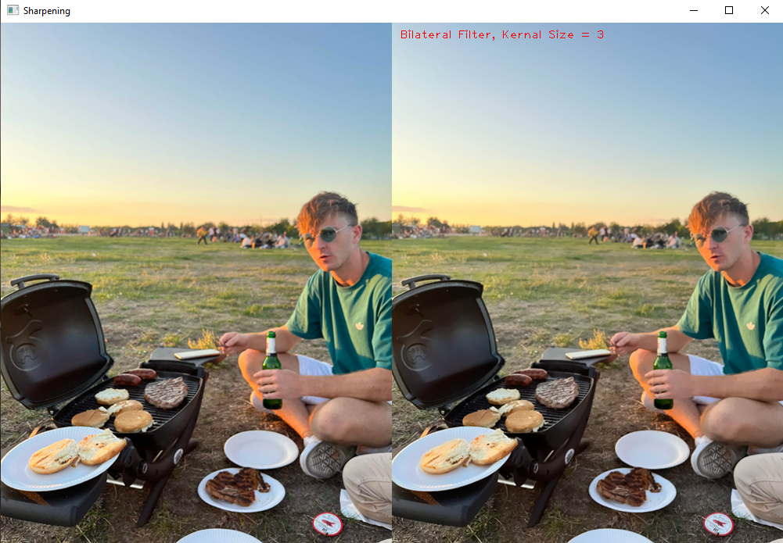

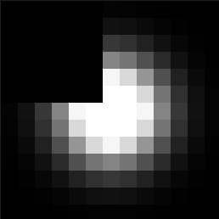

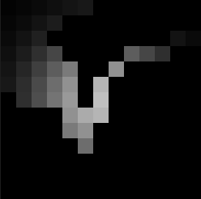 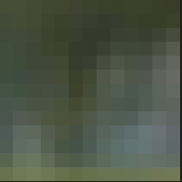

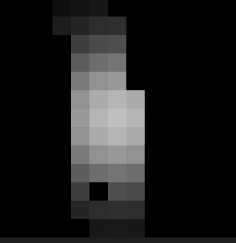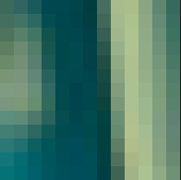

1. **Median Filter (Non-Linear Diffusion)**

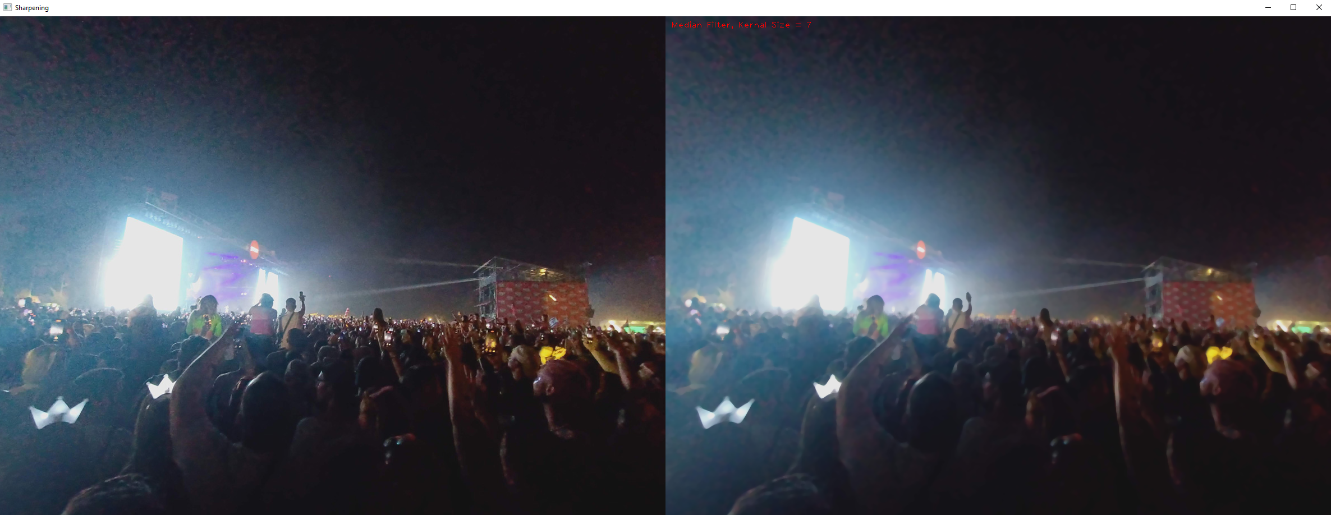

1. **Bilateral Filter (Non-Linear Diffustion)**

**Part 3: High-quality image resampling**

1. **Sub-Sampling (Minification)**
2. **Nearest Neighbour Scaling (Magnification)**
3. **Gaussian Pyramid (Non-Linear Diffusion)**
4. **Bilinear Interpolation Scaling (Both)**
5. **Bilateral Filter (Both)**